**Project Design Phase-II**

**Technology Stack (Architecture & Stack)**

|  |  |
| --- | --- |
| Date | 03October 2022 |
| Team ID | PNT2022TMID24504 |
| Project Name | Project – NEWS TRACKER APPLICATION |
| Maximum Marks | 4 Marks |

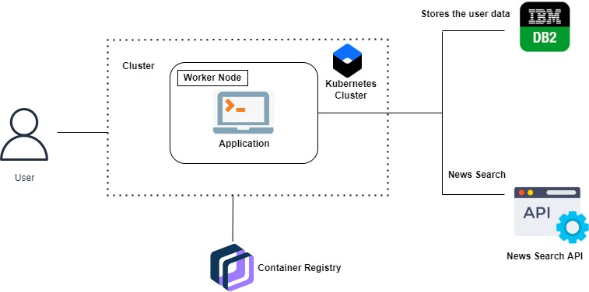**Technical Architecture:**

**Table-1 : Components & Technologies:**

|  |  |  |  |
| --- | --- | --- | --- |
| **S.No** | **Component** | **Description** | **Technology** |
|  | User Interface | The user can interact with the application to know about the trending news | HTML, CSS, JavaScript / Angular Js / React Js etc. |
|  | Application Logic-1 | The application contains this resource gives you basic understanding of Flask. | Flask. |
|  | Application Logic-2 | The application contains the news sub-division like geographical news ,economic news and society news. | IBM Watson STT service |
|  | Application Logic-3 | The user can view the growth of the economy in industry through graph. | IBM Watson Assistant |
|  | Database | Updating of trending news are stored in the MySQL database. | MySQL, NoSQL, etc. |
|  | Cloud Database | With the use of cloud , media coverage issue cannot be occurred. | IBM DB2. |

**Application Characteristics:**

| **S.No** | **Characteristics** | **Description** | **Technology** |
| --- | --- | --- | --- |
|  | Open-Source Frameworks | Flask is flexible and doesn’t require to use any particular projector code layout used in this application. | Python-Flask |
|  | Security Implementations | This can be access only by the journalist . So , It is a high Security. | Container registry,  Kubernetes Cluster. |
|  | Scalable Architecture | News Tracker is associate-economic access because helps to know about the daily activity of the world. | Container registry,  Kubernetes Cluster. |
|  | Availability | This application will be available to the all the user who are using this application. | Container registry,  Kubernetes Cluster. |
|  | Performance | The updation of trending news occurs without any interruption. So,it performance is good. | Container registry,  Kubernetes Cluster. |

# References:

<https://github.com/IBM-EPBL/Assignments-CApD/tree/main>

<https://ieeexplore.ieee.org/document/5616930>

<https://ieeexplore.ieee.org/document/1565880>

<https://ieeexplore.ieee.org/document/8703401>